Lab No. 8

Polymorphism

Method Overriding (Virtual Methods) in Python

Lab Objectives | Following are the lab objectives:  - Understand method overriding  - Implement method overriding
Student ID | 10011 | Student Name |  | Sajjal Tariq
 | Marks |  | Obtained Marks |  | Comments
Task 1 | 20
Task 2 | 20
Task 3 | 20
Total Marks | 60
 | Lab Instructor

Lab Objectives and CLOs Mapping

Lab Objectives | CLOs
Lab Objectives | a | b | C
1
2

Instructions
- This is individual Lab work/task.
- Complete this lab work within lab timing.
- Discussion with peers is not allowed.
- You can consult any book, notes & Internet.
- Copy paste from Internet will give you negative marks.
- Lab work is divided into small tasks, complete all tasks sequentially.
- Show solution of each lab task to your Lab Instructor.
- In-Lab Exercises/Tasks
- Write your code at provided space after each question.
- You need to upload code for all tasks at Google Classroom.

Lab Tasks
Task 1 (20 mark)
Write a program that starts with a base class employee. This class contains employee’s name and employee number. From this class inherit three other classes which are manager, scientist and laborer. The manager and scientist classes should contain additional information about these categories of employee and member functions.
Override the function which calculate salary of employee in its each child class.
Manager class:
- Additional attributes:
  - base_salary (float or integer) – Manager's base salary
  - bonus (float or integer) – Manager's bonus
- Additional member functions:
  - calculate_salary() – Overrides the base method to return salary including bonus
  - assign_task(task) – Assigns a task to the manager's department
Scientist class:
- Additional attributes:
  - base_salary (float or integer) – Scientist's base salary
  - research_allowance (float or integer) – Scientist's research allowance
- Additional member functions:
  - calculate_salary() – Overrides the base method to return salary including research allowance
  - submit_research(title) – Submits a research report with the given title
Laborer class:
- Additional attributes:
  - hourly_rate (float or integer) – Laborer's hourly rate
  - hours_worked (integer) – Number of hours worked
- Member functions:
  - calculate_salary() – Calculates salary based on hourly rate and hours worked
Code:
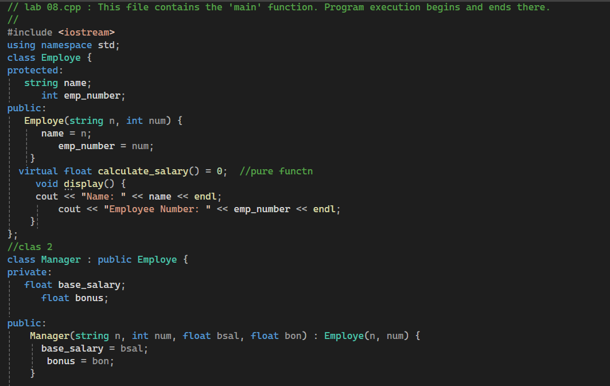
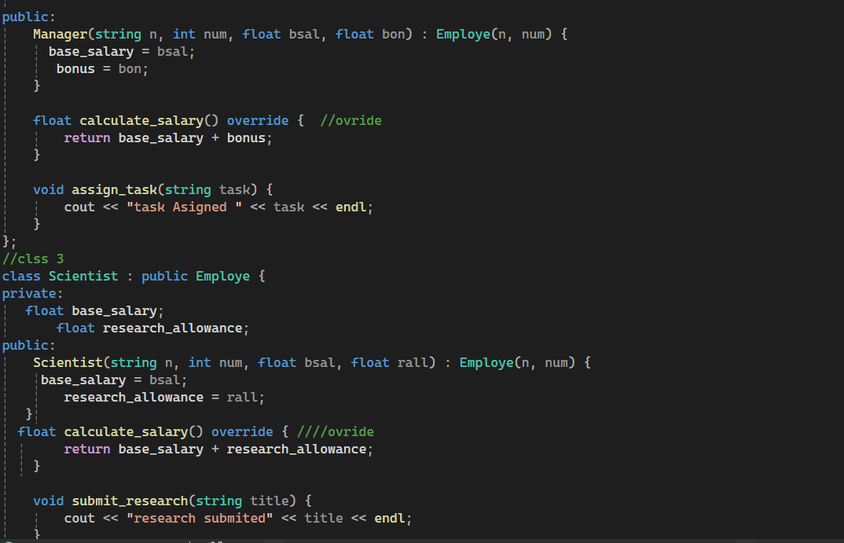
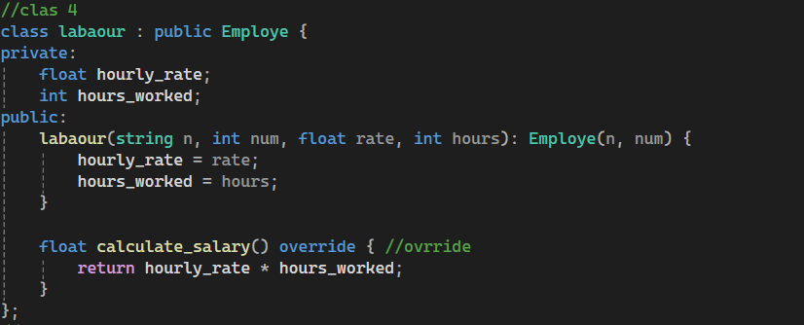
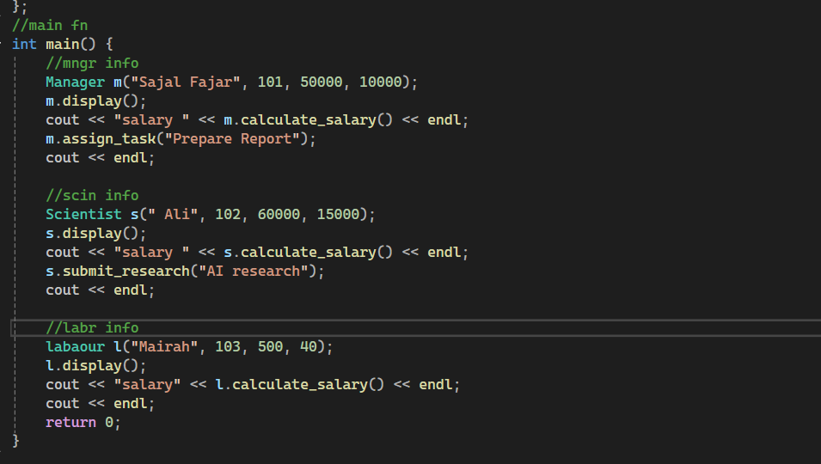
Output:
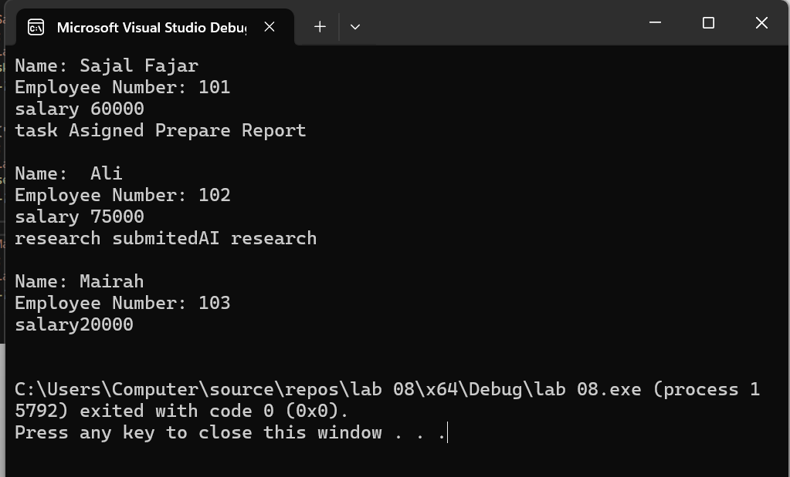

Task 2 (20 mark)
See following real world objects;
- Medicine
- Tablet
- Syrup

Create a C++ program using polymorphism with the following scenario:
- Define an abstract base class Medicine with attributes like name and manufacturer.
- Include an abstract method how_to_take() and a regular method display_info().
- Create two derived classes: Tablet and Syrup, each overriding how_to_take() with specific instructions.
- Demonstrate polymorphism by writing a function that takes a Medicine object and calls both display_info() and how_to_take() on it.
- Instantiate objects of both subclasses and show polymorphic behavior through iteration.
Code:
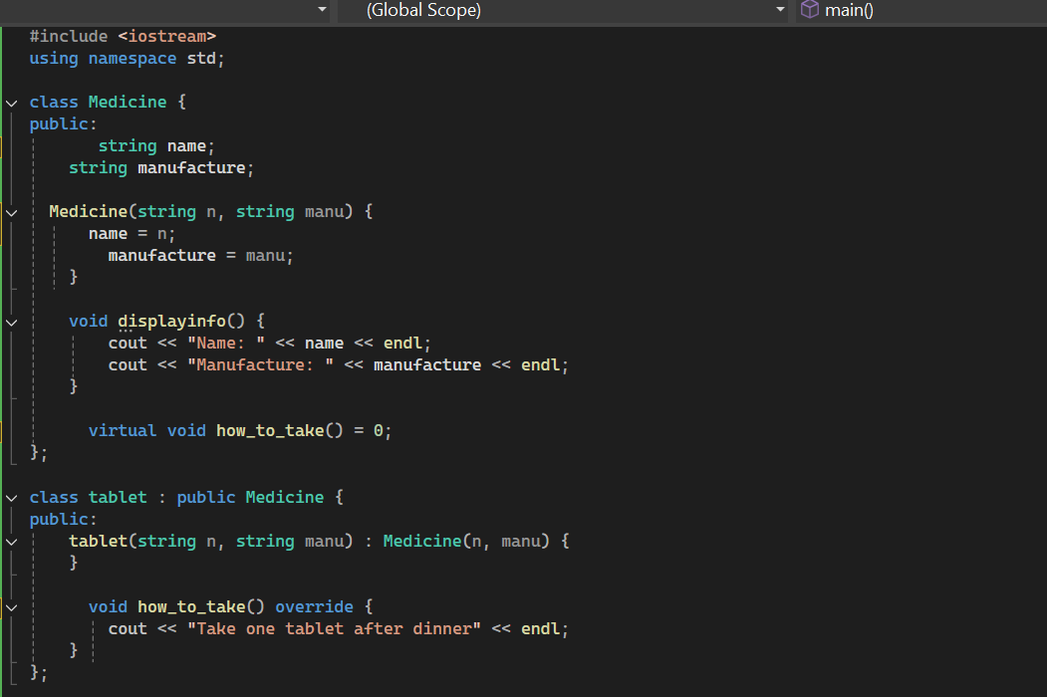
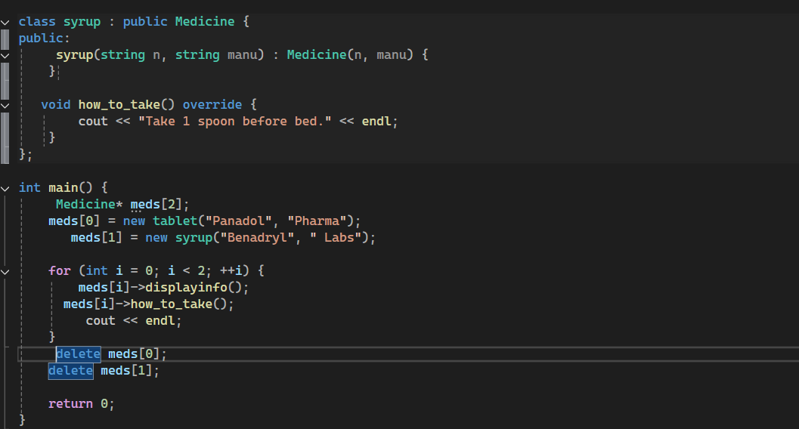
Output:
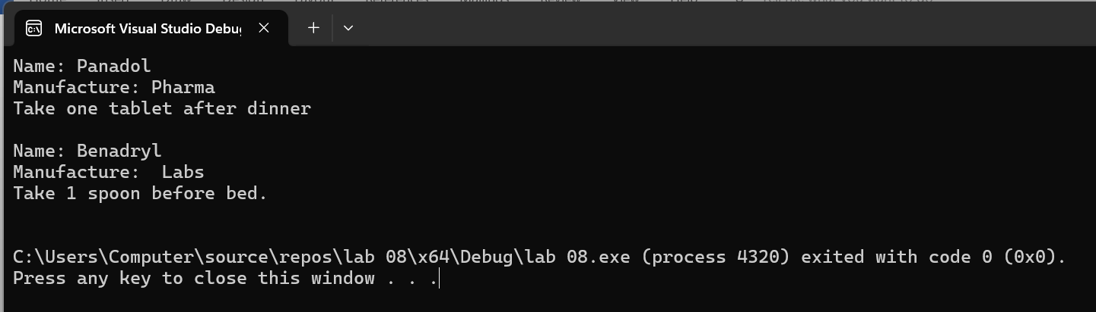

Task 3 (20 mark)
See following UML diagram to complete the tasks.
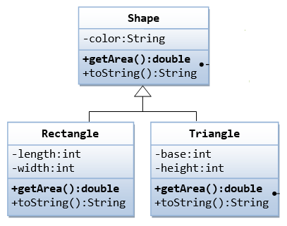
You need to implement;
- All Classes with their relationship
- Implement abstract classes, abstract methods and virtual methods
Code:
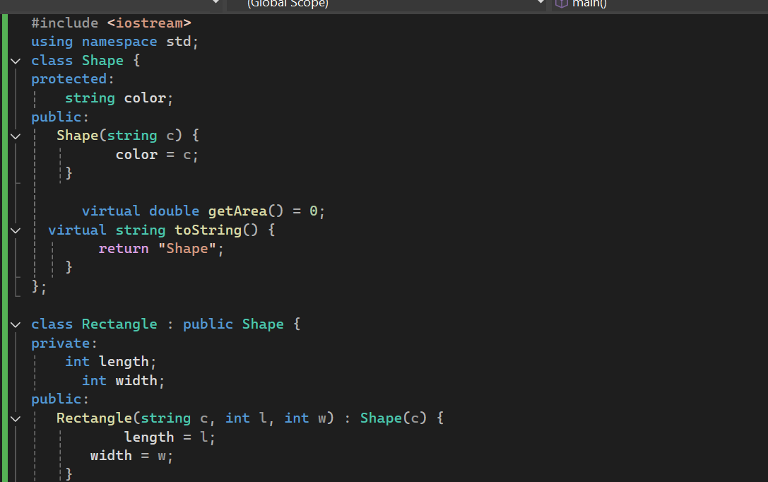
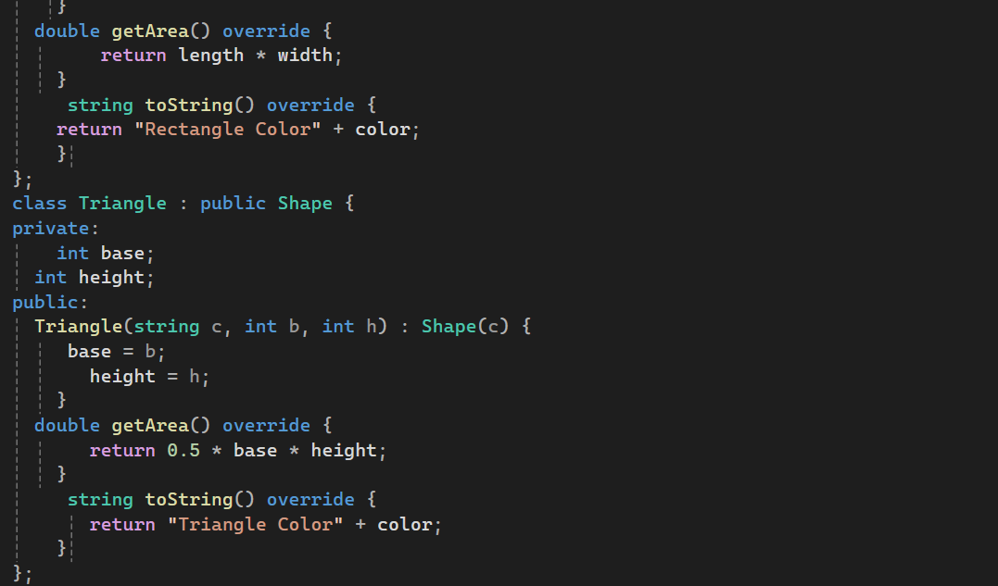
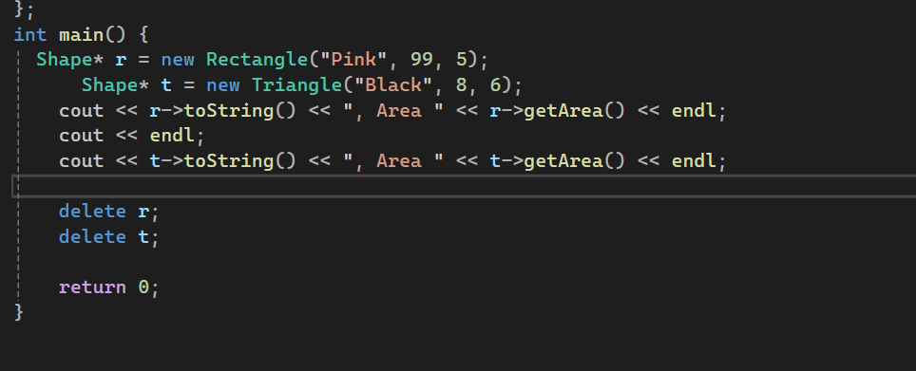
Output:
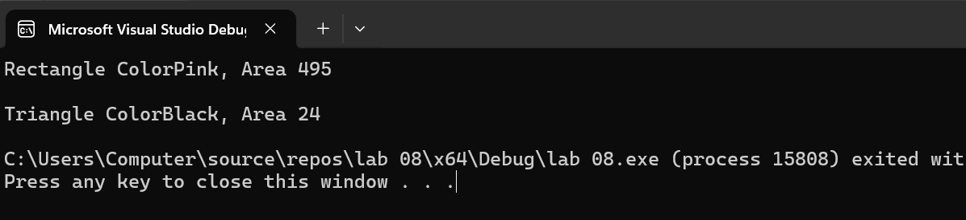
Extra Tasks
Write a program to show calling of overridden function from the child classes defined in above tasks.

